Assignment 4
Retrieving Information from Tables.
- Write a select command that produces the order number, amount, and date for all rows in the Orders table.

Query:-
mysql> select Onum, Amt, Odate from Orders;

Output:-

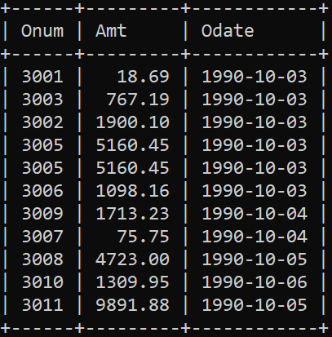

- Write a query that produces all rows from the Customers table for which the salesperson’s number is 1001.

Query:-
mysql> select * from CUSTOMERS
-> where Snum = 1001;

Output:

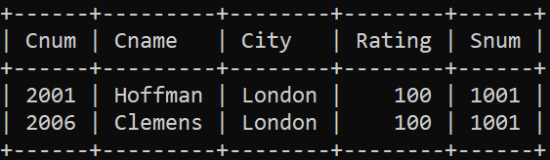

- Write a query that displays the Salespeople table with the columns in the following order: city, sname, snum, comm.

Query:
mysql> select city, sname, snum, comm from SALESPEOPLE;

Output:

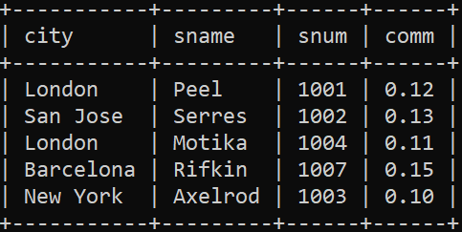

- Write a select command that produces the rating followed by the name of each customer in San Jose.

Query:
mysql> select Rating, Cname from Customers
-> where city = 'San Jose';

Output:

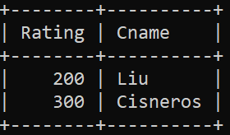

- Write a query that will produce the snum values of all salespeople (suppress the duplicates) with orders in the Orders table.

Query:

mysql> select distinct snum from ORDERS;

Output:

